**PostgreSQL Data Warehouse Read-Only Login Creation**

Introduction

This Standard Operating Procedure (SOP) document outlines the process for creating and managing read-only login credentials for the Data Warehouse. These credentials ensure users can access data for querying and reporting purposes without the ability to alter or delete it, thereby preserving data integrity and security. Proper implementation of read-only access controls is crucial for maintaining the reliability of the data warehouse.

Steps to follow

1. Login to the data warehouse using the PG-Admin console. This application is available on every Apprise Server.

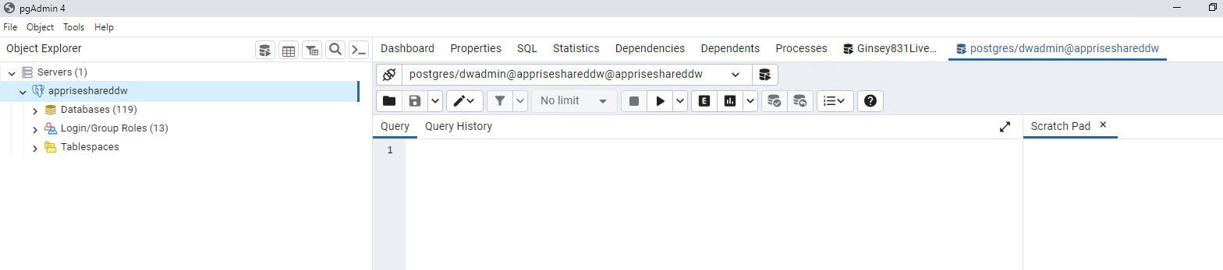

1. Once logged in, expand the database dropdown. Select the database and right click on same for which login needs to be created. Select Query Tool. It will open a writing pad. Paste below script and modify the username. Username should follow below pattern instructions

* Username should start with APTEANBI_
* Preceding with Customer Name, Database Name, Database Version, Environment Initial, and ‘RO’ for read-only.

-- Role: "APTEANBI_VI820LRO"

-- DROP ROLE IF EXISTS "APTEANBI_VI820LRO";

CREATE ROLE "APTEANBI_VI820LRO" WITH

LOGIN

NOSUPERUSER

INHERIT

NOCREATEDB

NOCREATEROLE

NOREPLICATION;

1. Executing above script will create the user login, which will be visible in left hand side panel drop down Login/Group Roles shown below

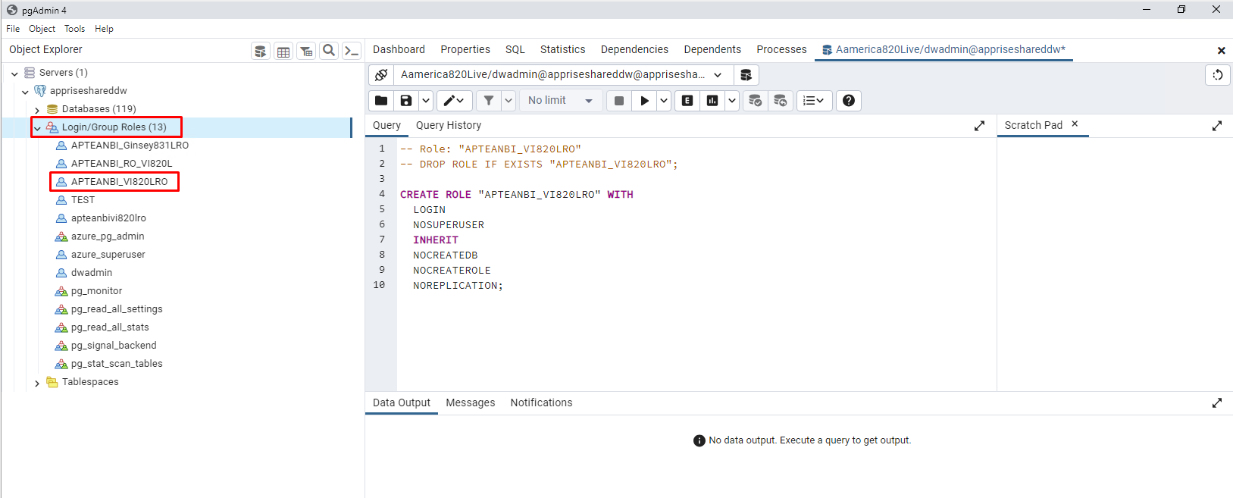

1. Right click the new login created, select properties and click on definition section, provide password shown as below. Password should be of below characteristics

* 12 characters long
* at least 1 lower case letter
* at least 1 upper case letter
* at least 1 number
* at least 1 special character

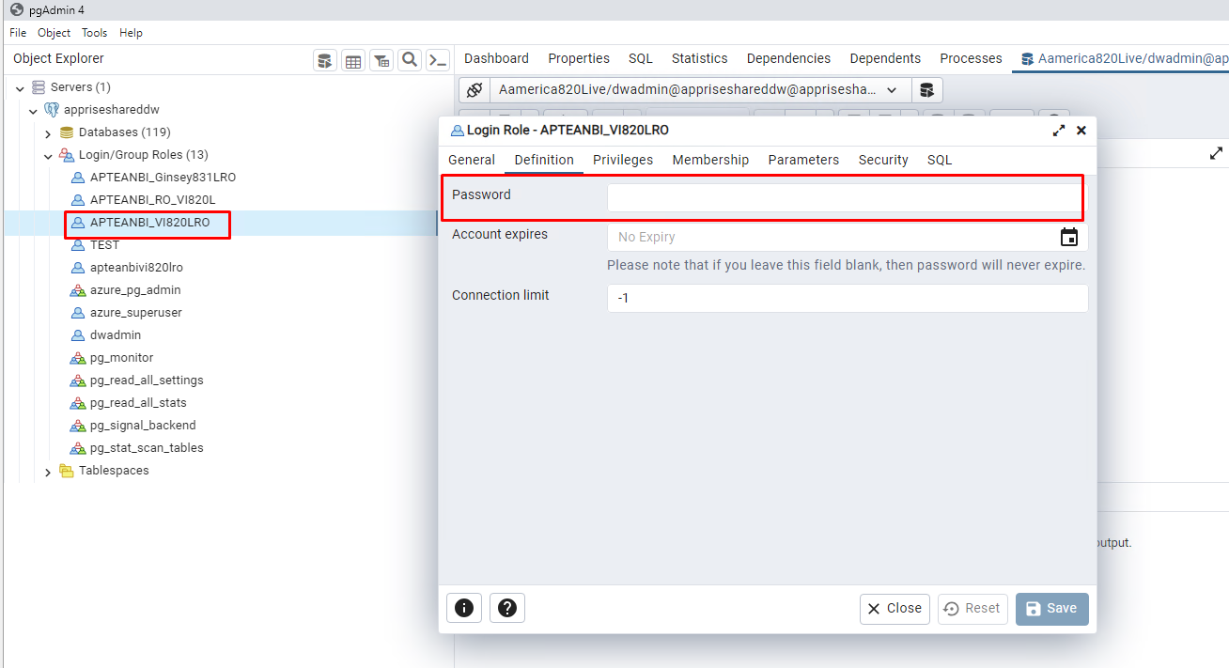

1. Select your database and drop down, expand schema, and select the schema named with systemID. Right-click on schema and go to properties. Select the Security tab add your login created and provide Usage permission shown as below and save.

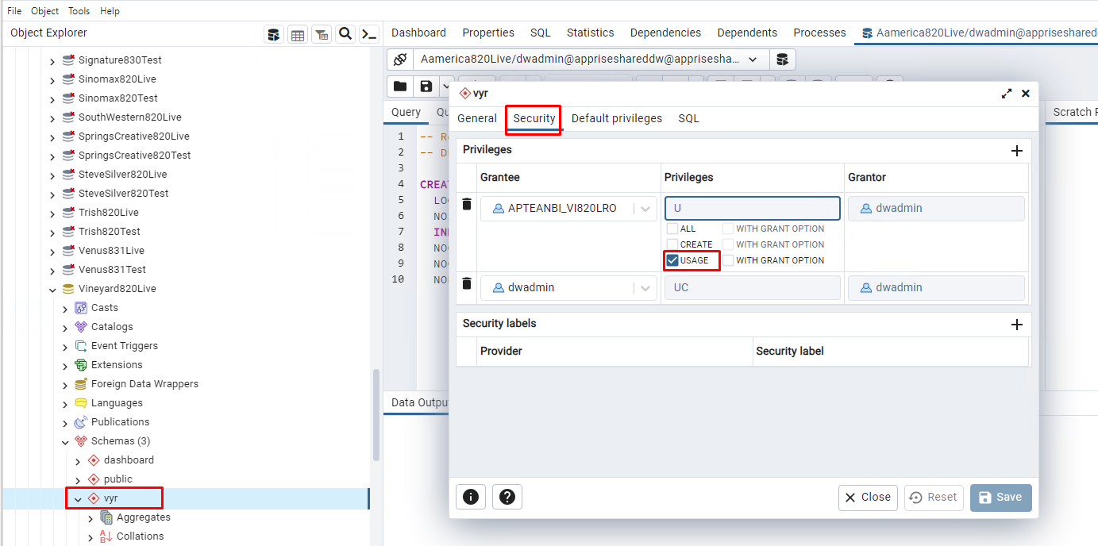

1. expand the schema again, expand tables drop-down and right-click select Grant wizard shown as below

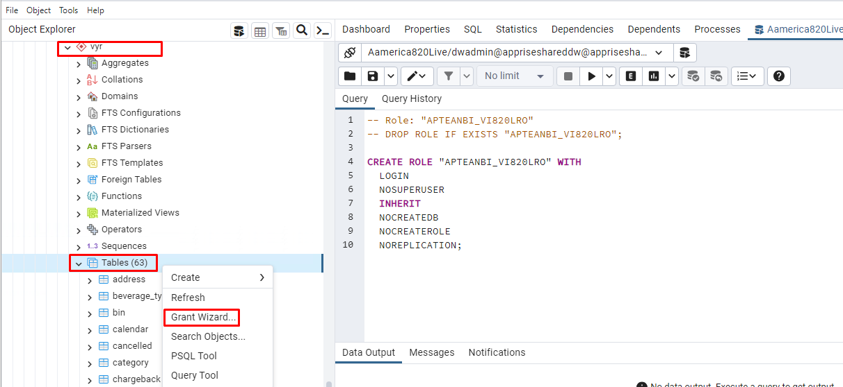

1. Once clicked on Grant Wizard, it will open the prompt to provide permissions on all tables, in object selection select all the tables to provide permissions on and click next.

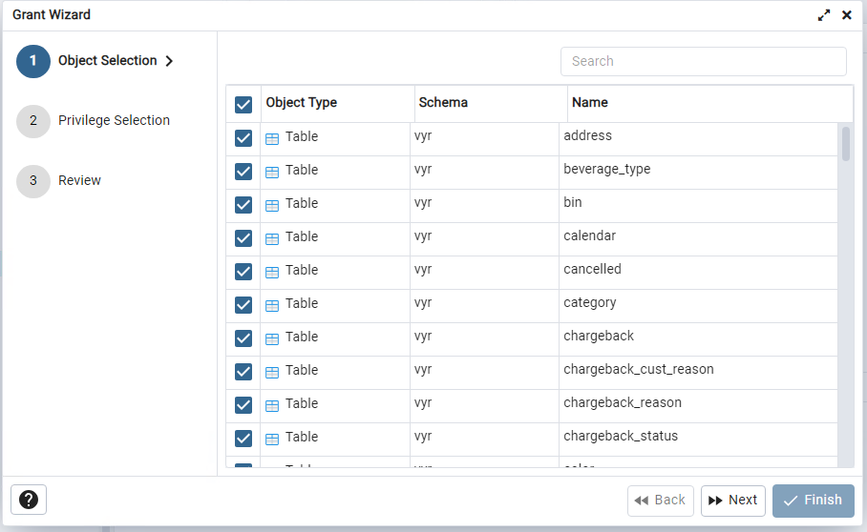

1. In the privilege section click the ‘+’ icon in the right side corner of the screen and add your user created. Provide only select permission shown as below and click Next.

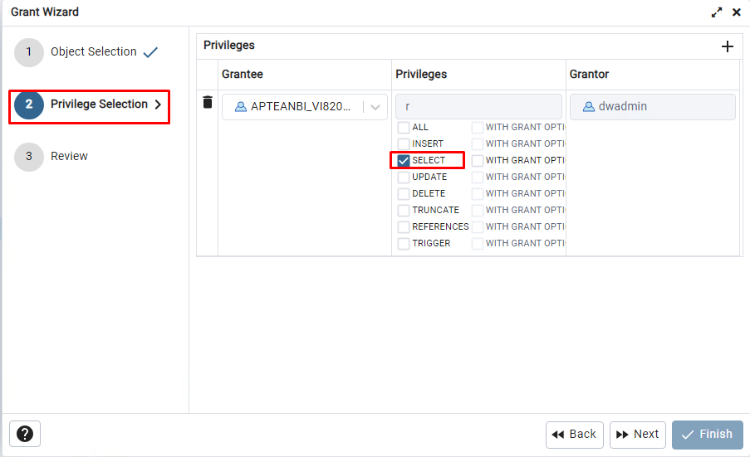

1. In last Review tab, click finish, it will execute the script and permission on all tables of the selected database will be granted.

